Homework 10: Burp Suite Intro

Step 1: Configure Burp Suite

1. Check for existing proxies:
   * Open a terminal and type: env | grep -i proxy

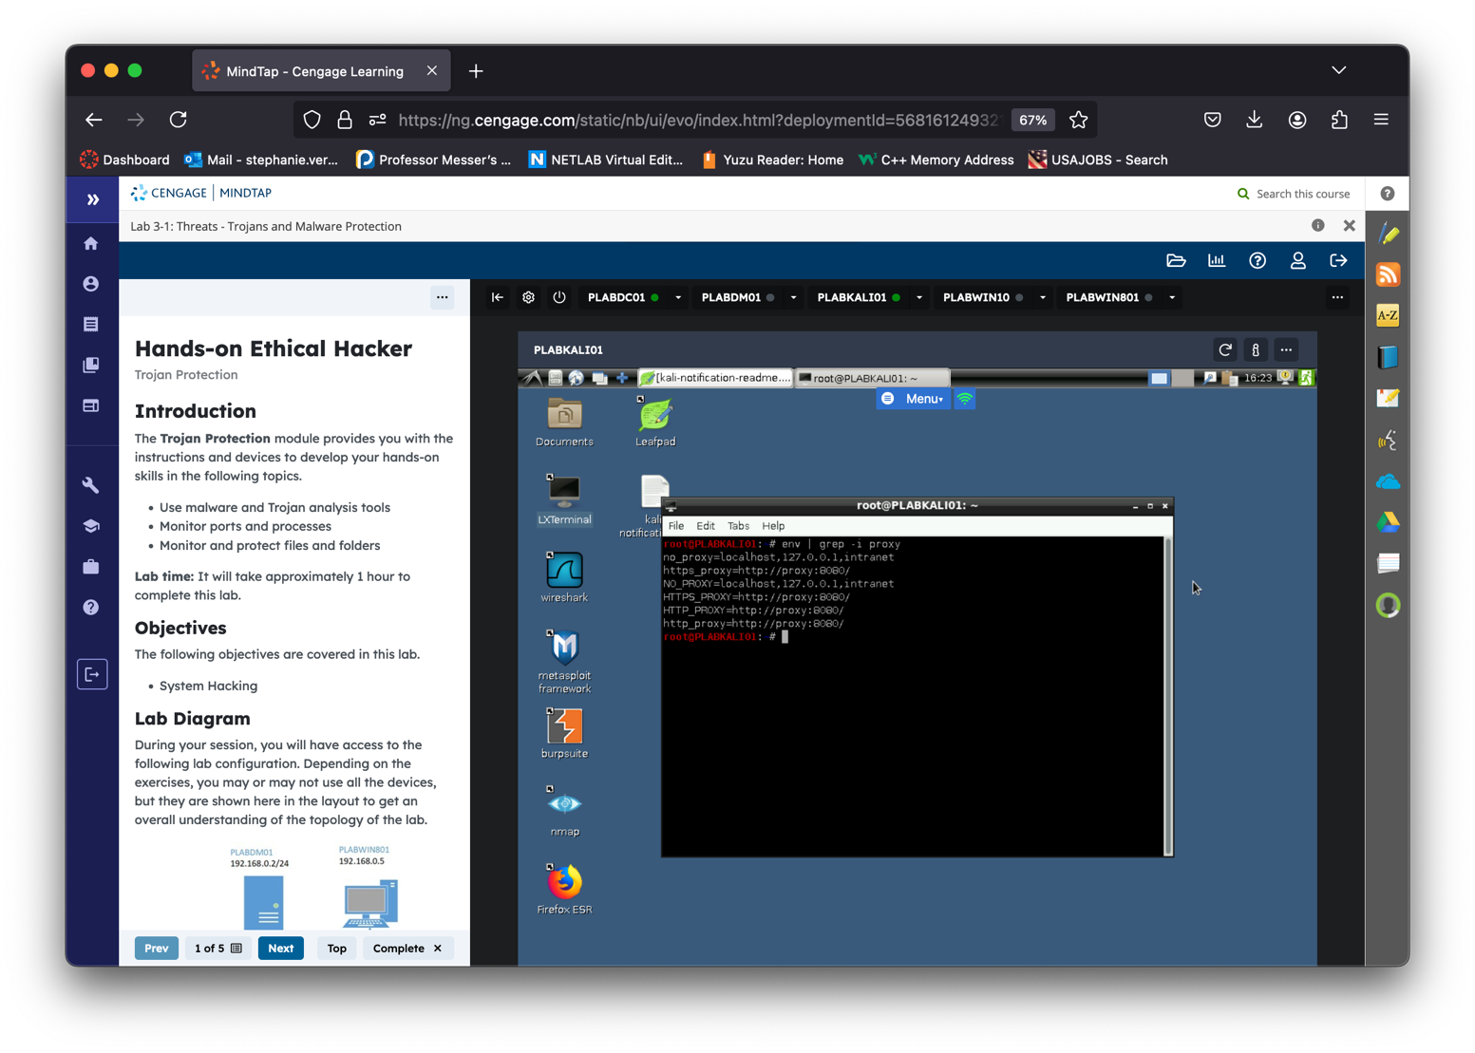

* Take note of this; you can now close the terminal
* Start Burp Suite by double-clicking the icon on your desktop (or finding it in your start menu)
  + It might take a moment to boot up, you may need to click the desktop shortcut twice
  + You may need say "*I Accept"* for a user agreement before proceeding
* Continue clicking through for a "*Temporary project*" setup and Use Burp defaults, then "*Start Burp*"
  + It's not necessary to update your Kali software if prompted
  + You should now see the main Burp *Dashboard*

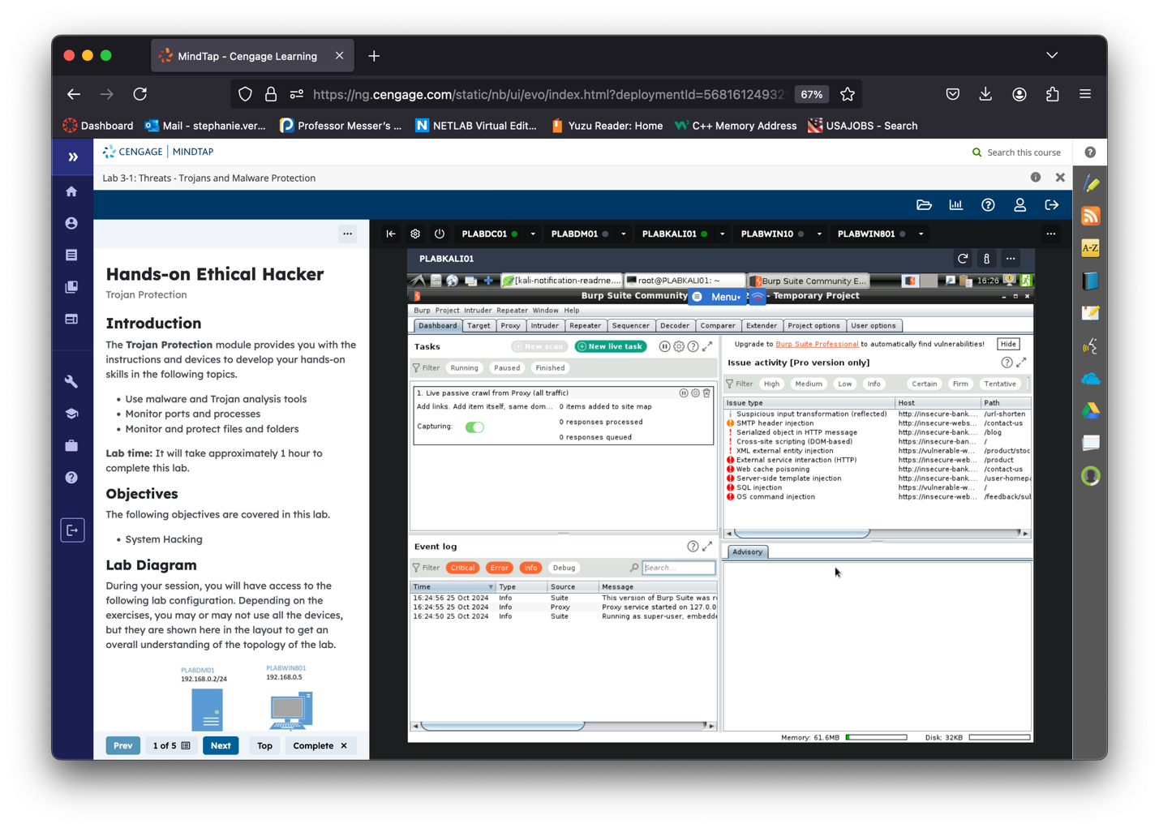

1. Configure Upstream Proxy:
   * Go to User options > "Upstream Proxy Servers" > "Add".
   * Set:
     + Destination Host: \*
     + Proxy host: proxy
     + Proxy port: 8080
     + Authentication type: none

Make sure to click ok.

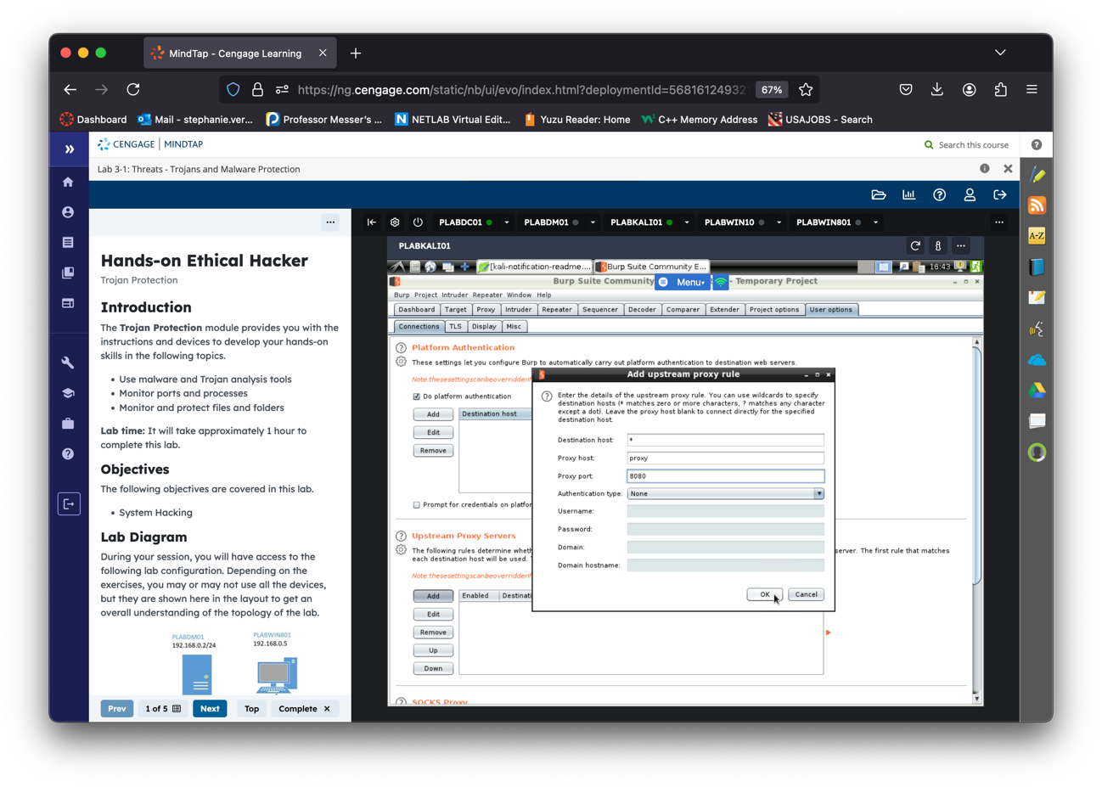

* Go to Proxy > Options.
* Edit Bind to Port to 8088 and Bind to Address to 127.0.0.1.

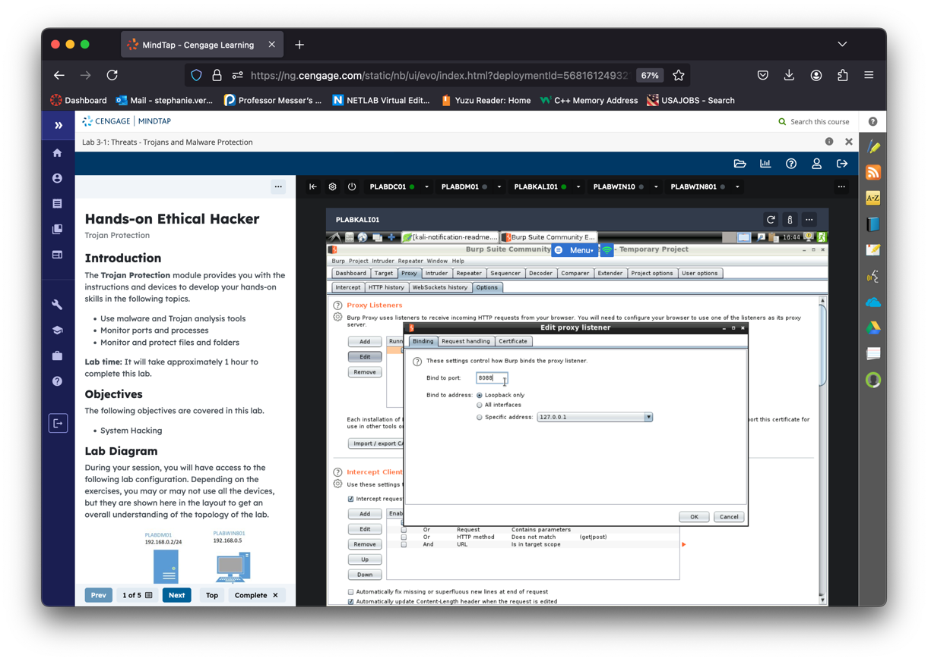

* Go to Proxy > Intercept and set it to "Intercept is off."

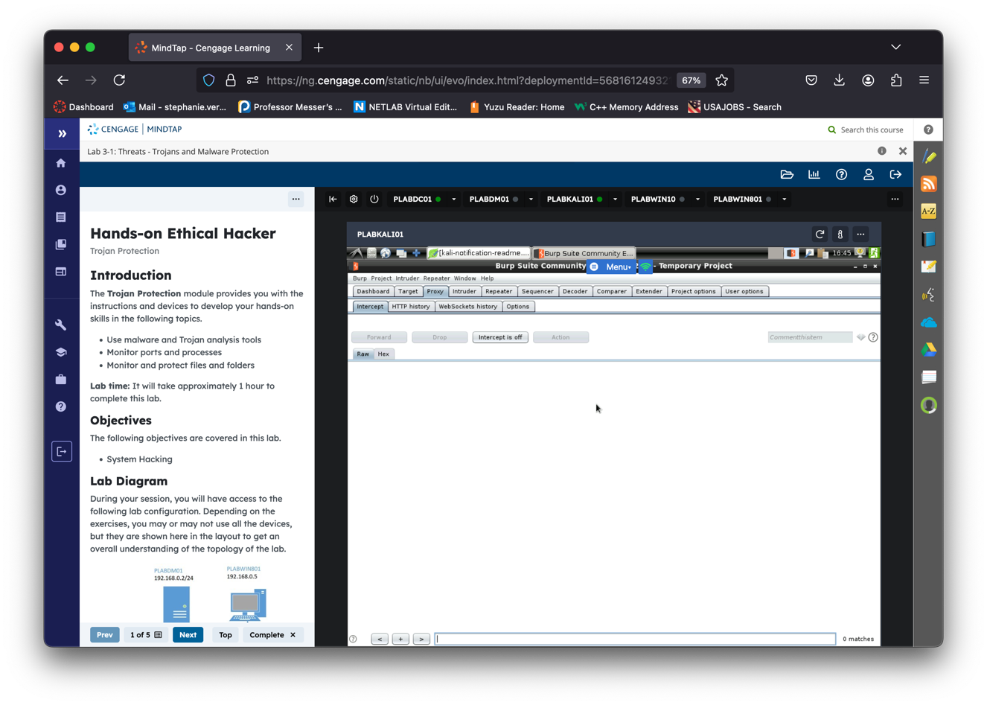

* Go to Proxy > HTTP history.

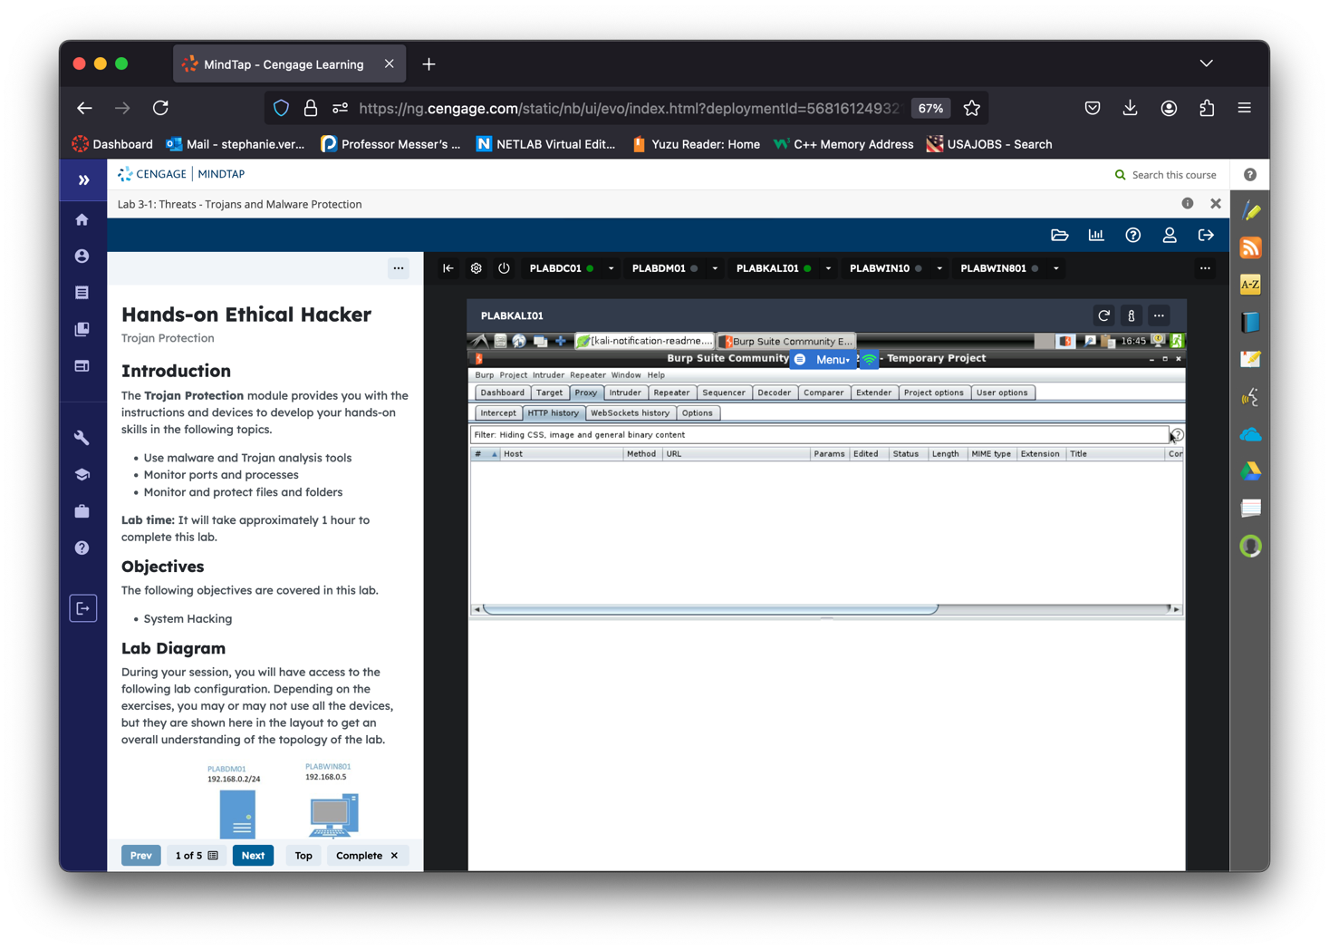

Step 2: Set Up Firefox ESR

1. Update Firefox ESR:
   * Open a terminal and run:
     + sudo apt update
     + sudo apt install firefox-esr

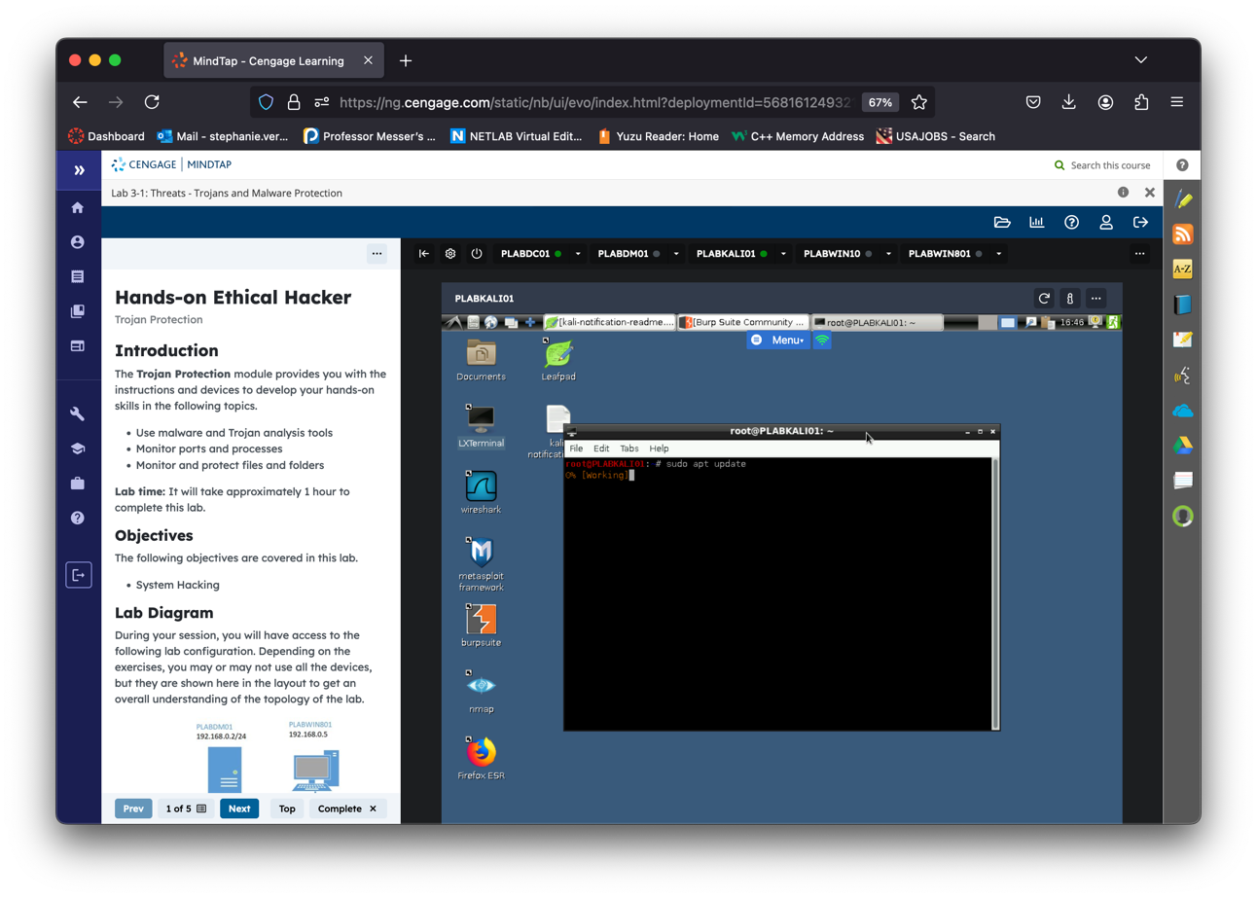

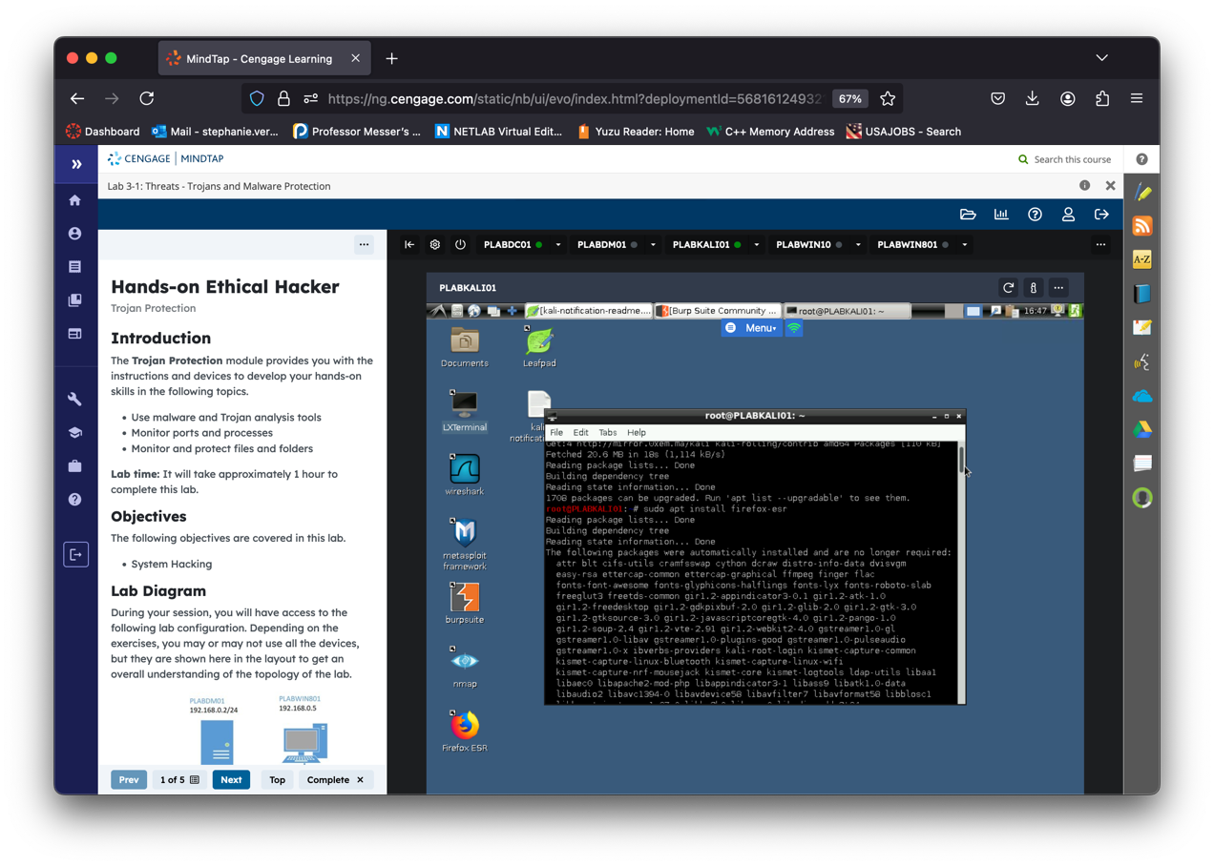

* type Y to continue as shown bellow:

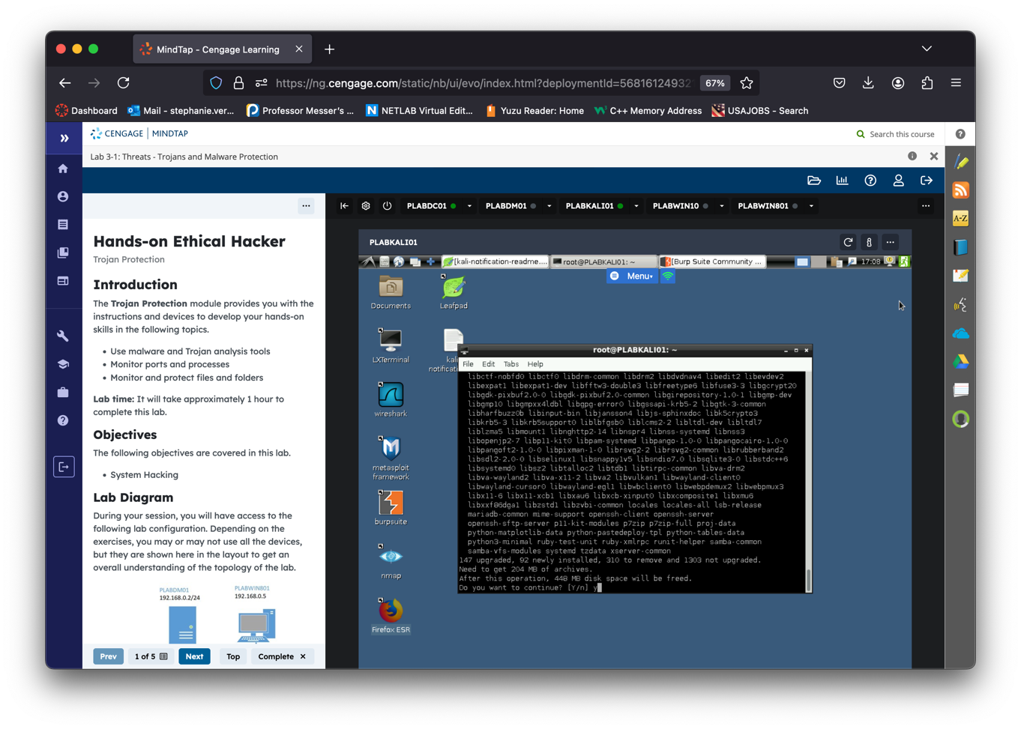

* Enter “q”

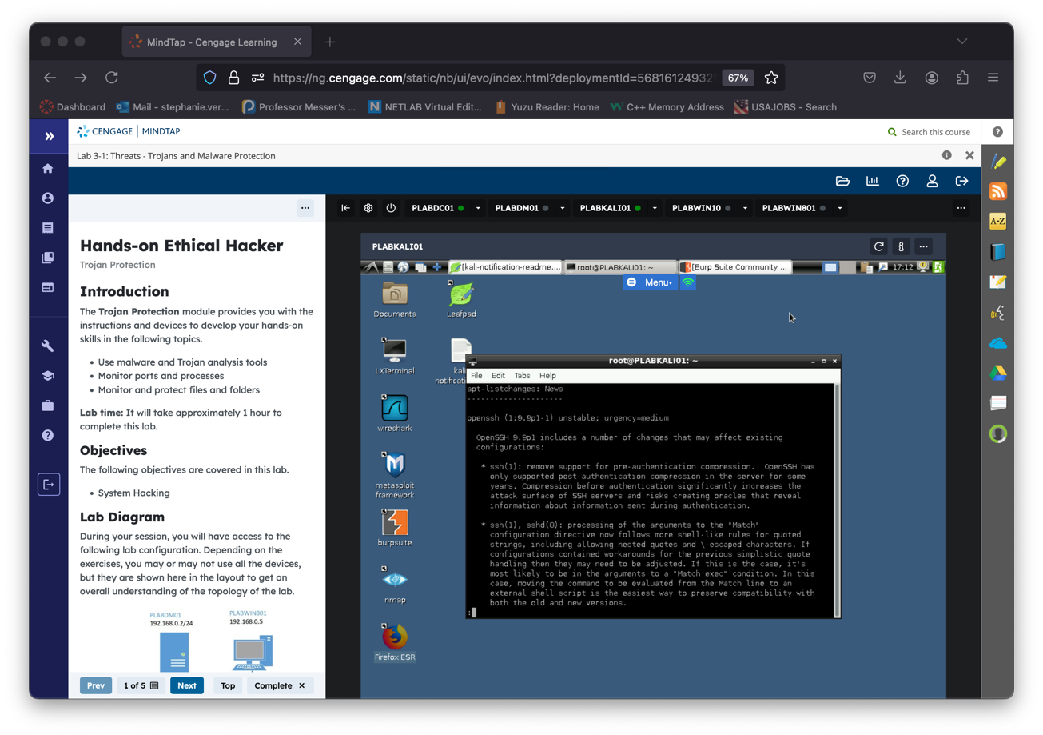

* Select yes and click enter

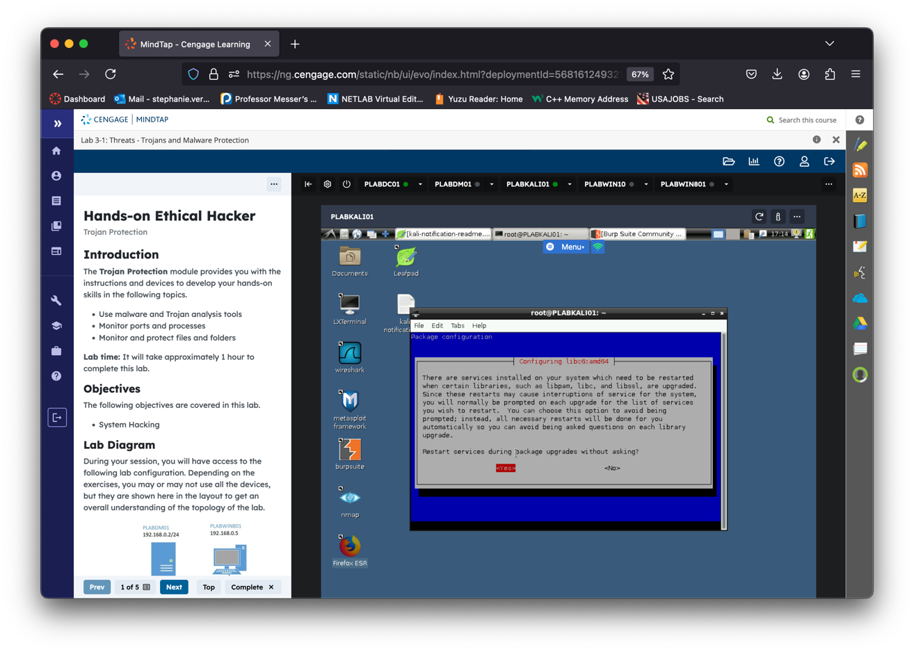

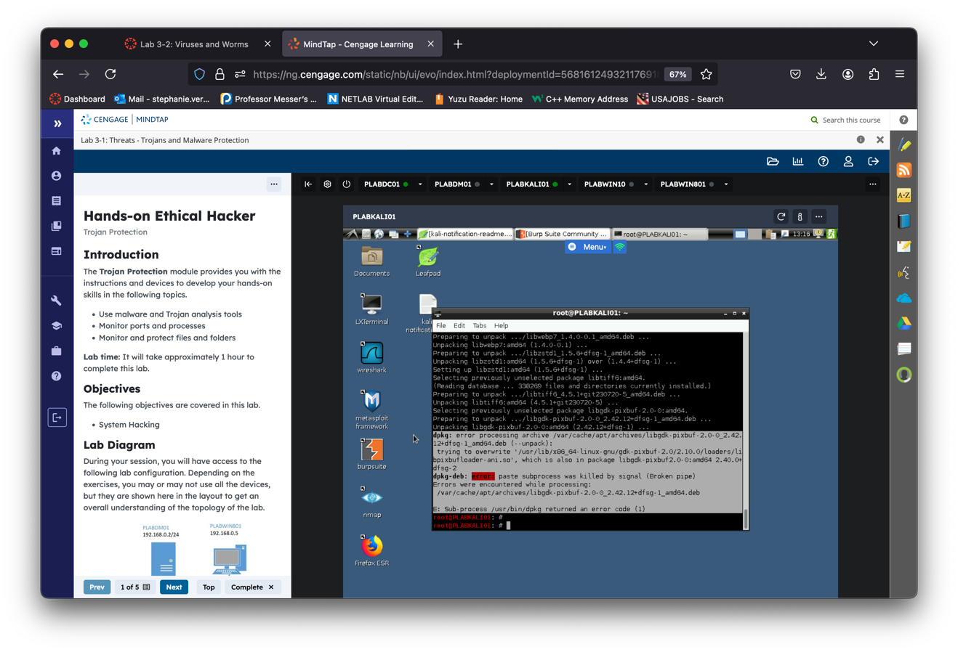

* Note: I did receive an error message, displayed on image above.
* I enter the following command to solve:

sudo apt update

sudo apt –fix-broken install

I additionally tried to reinstall firefox-esr by entering the following command:

sudo apt install firefox-esr

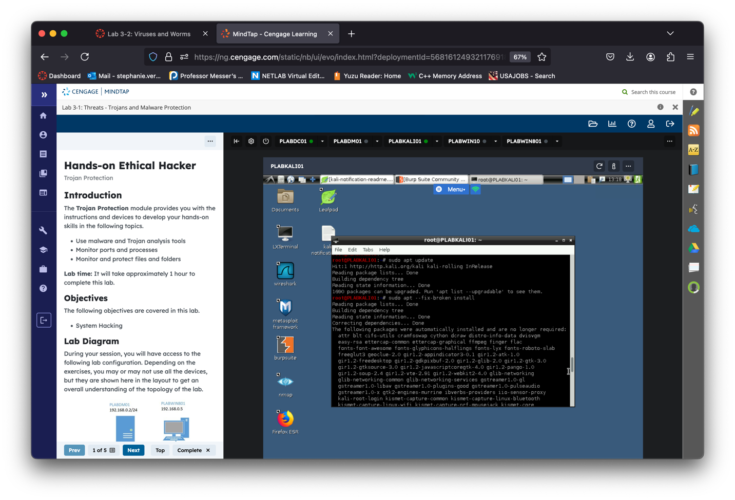

* Enter Y once again.

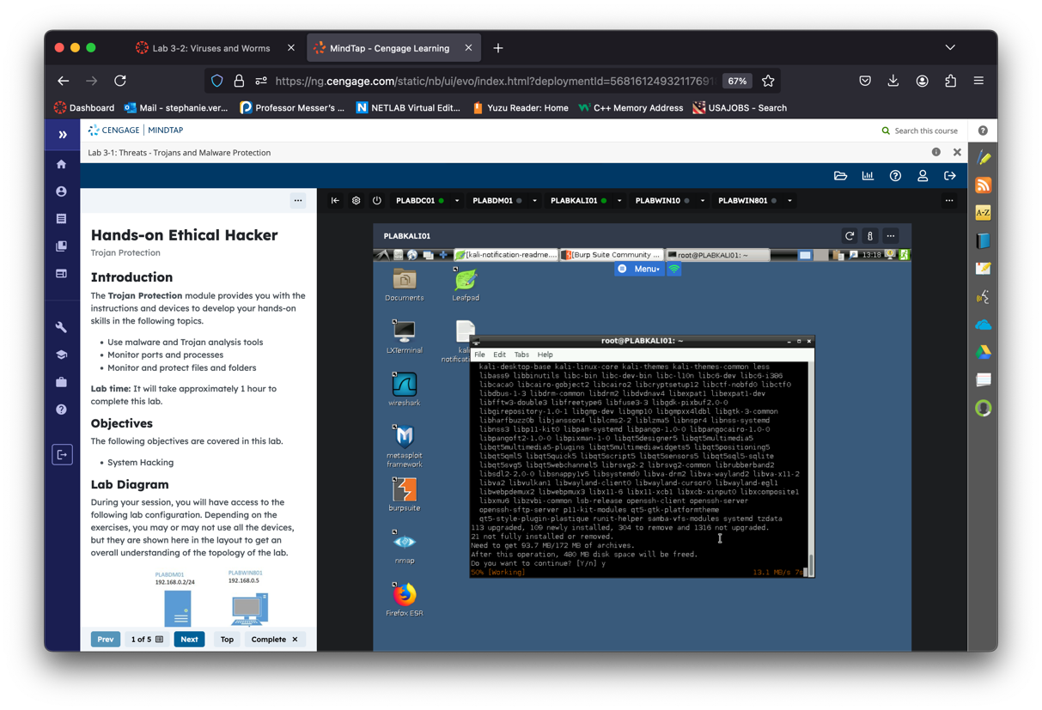

* Let it run

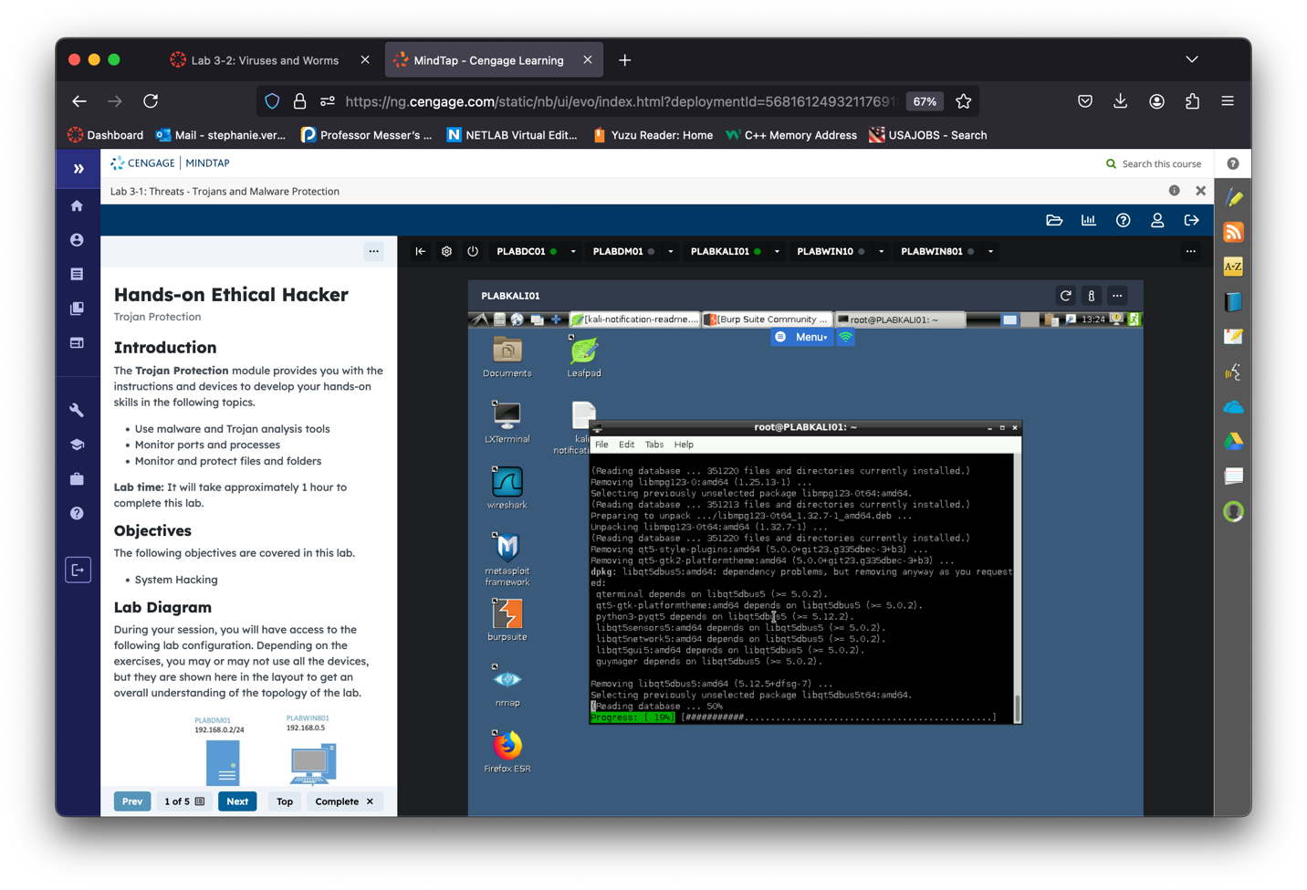

* Once I received the next error message shown bellow:

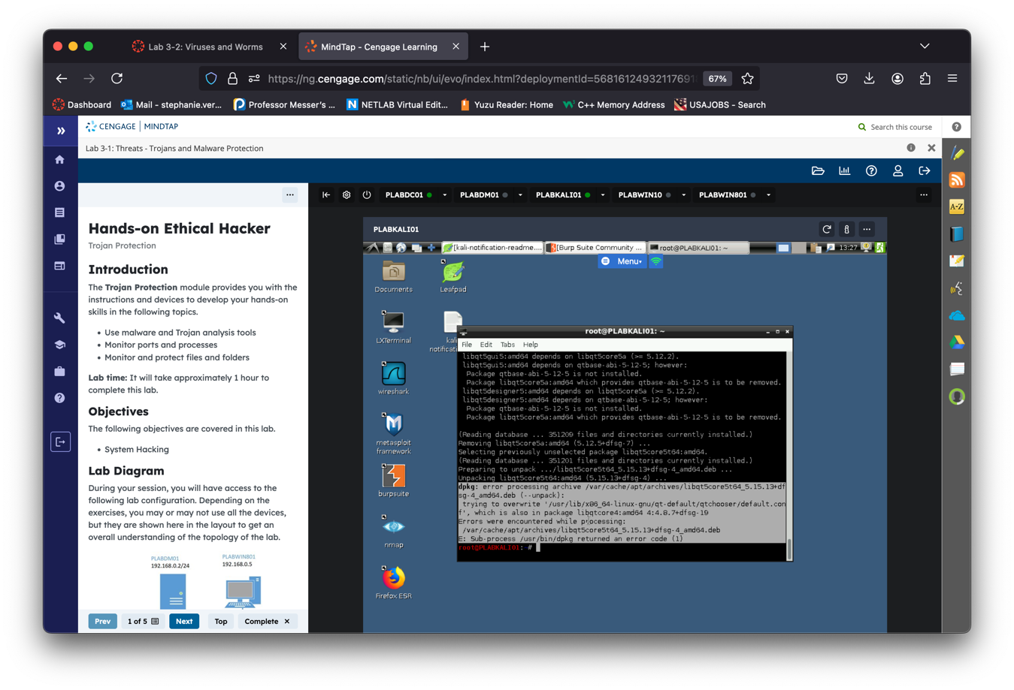

* I continue by clearing & reconfigure dpkg by entering the following command:

sudo dpkg –configure. -a

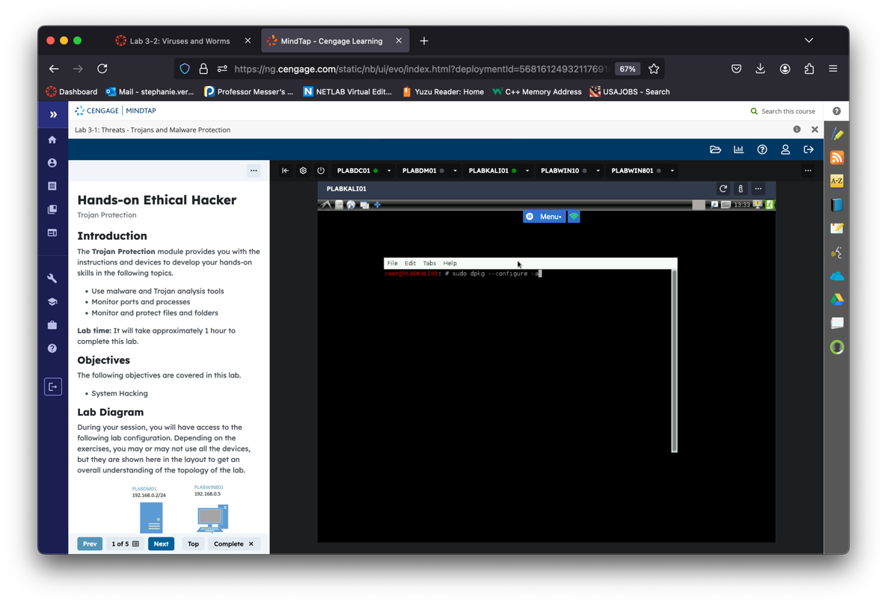

Computer rebooted and I had to log back in with credentials provided

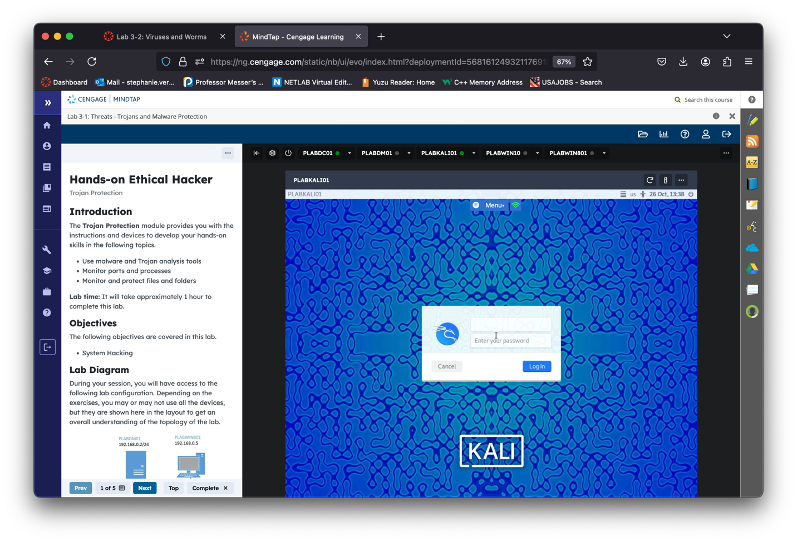

Configure Proxy:

* + Open Firefox ESR and go to Settings > Network Settings.
  + Choose "Manual proxy configuration," set HTTP Proxy to 127.0.0.1 and Port to 8088.

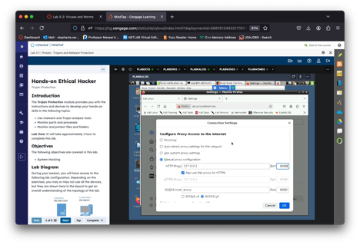

1. Install Burp’s CA Certificate:
   * Go to http://burp in Firefox, download the CA Certificate.

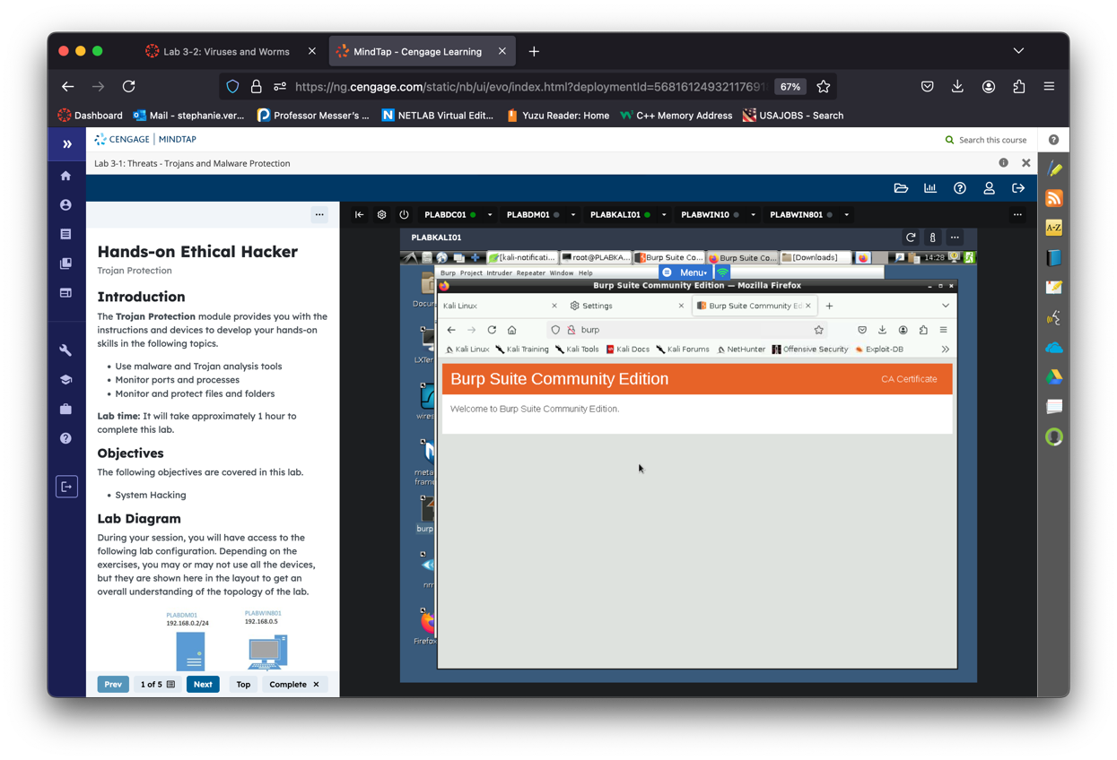

* + Import it through Settings > Privacy & Security > Certificates.

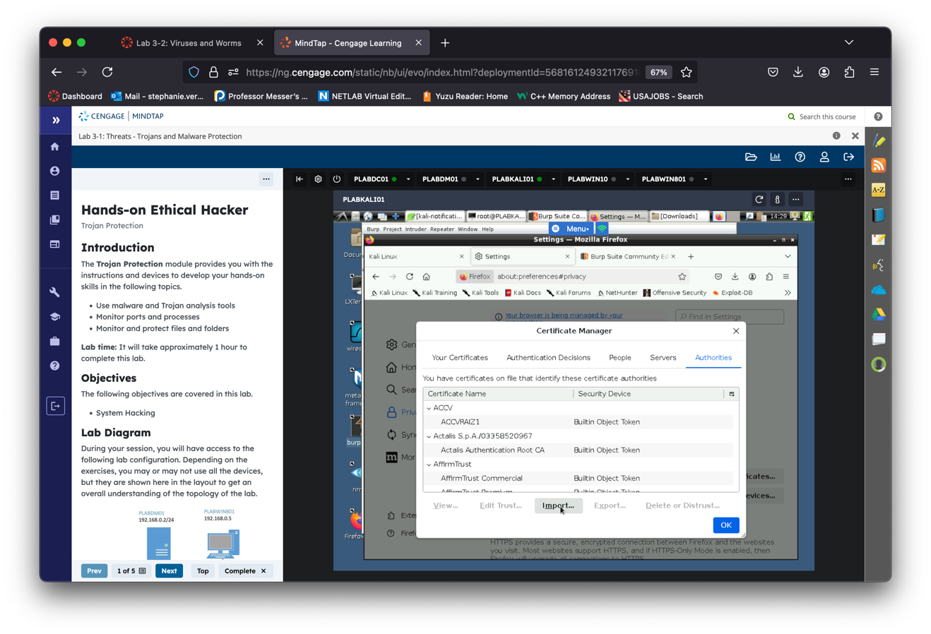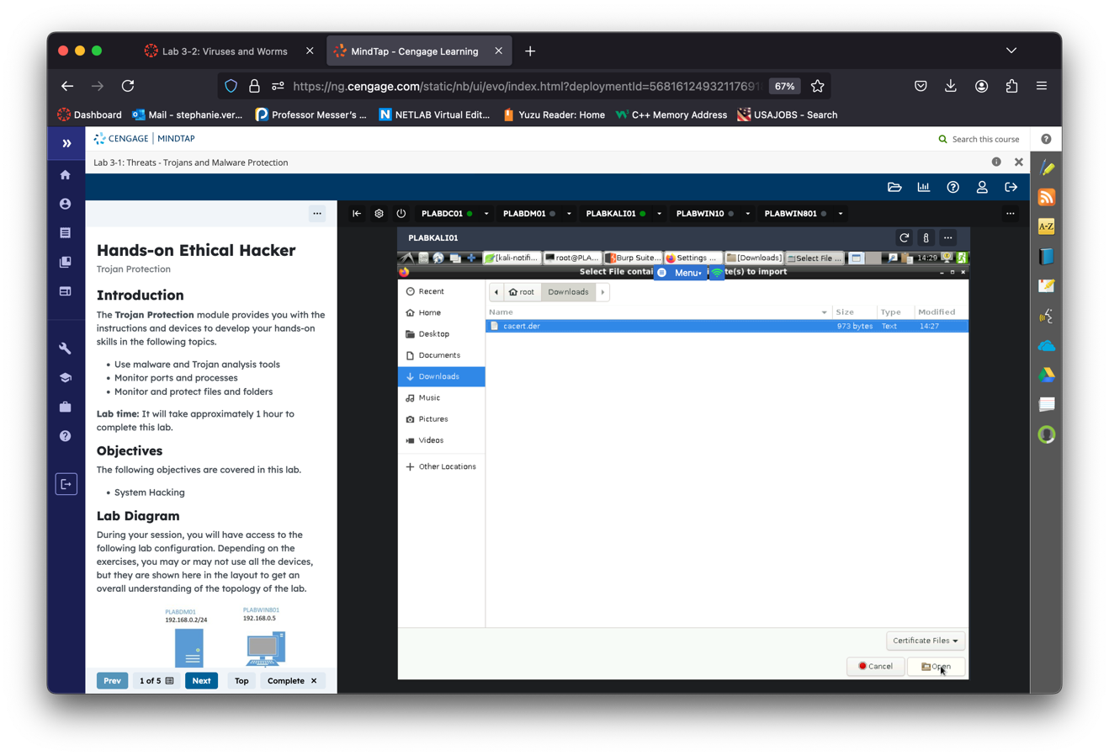

* Check both boxes to trust it and press "OK", then "OK" again

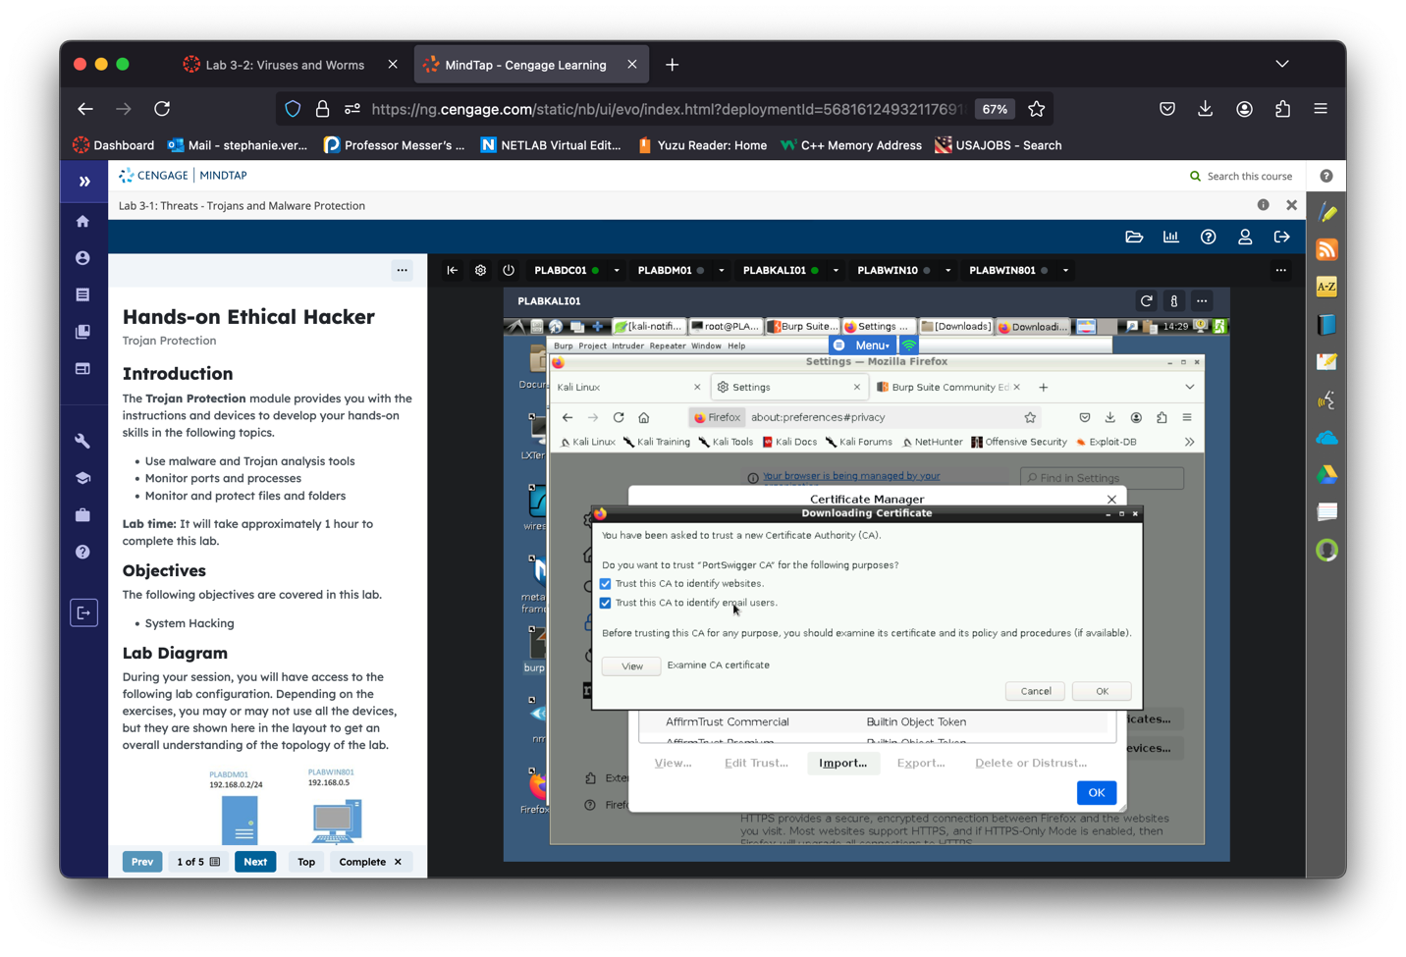

Step 3: Set Up Juice Shop Account

1. Open Juice Shop in Firefox: <https://juice-shop.herokuapp.com/#/>.

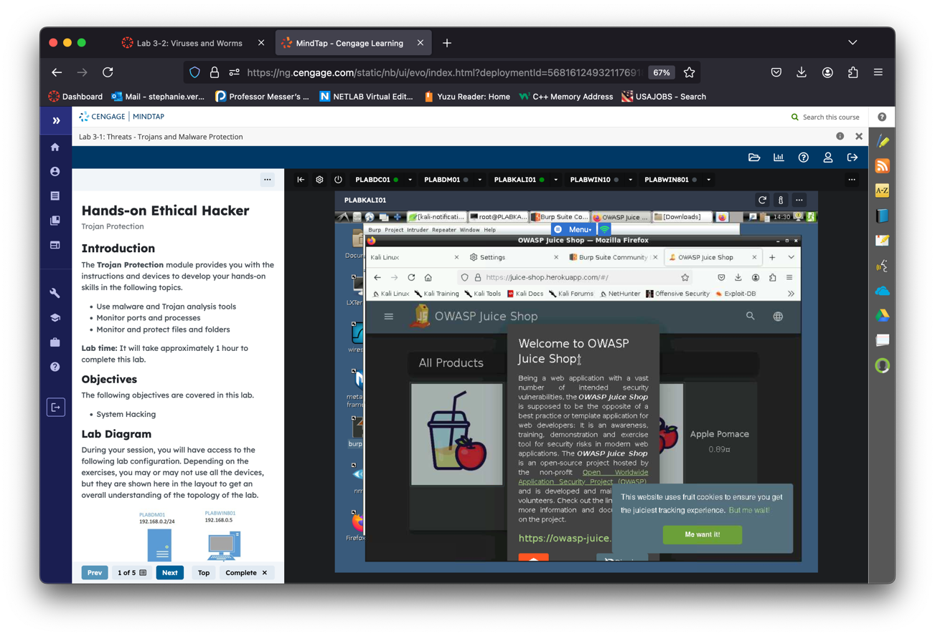

* " If prompted by a pop-up, select "Dismiss" or "Me want it!"
* " Click on the "Account" button in the top right corner of the page and press "Login
* Scroll down to the link that lets you create a new account, "Not yet a customer?"
* Fill in the form with fake account information (e.g., "test@example.com" for the email and "testpassword" for the password), and press "*Register"*

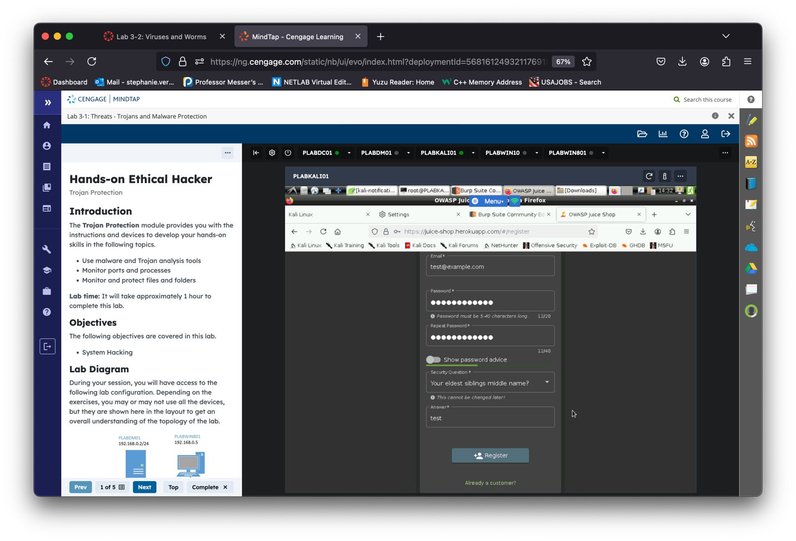

* Login after creating the fake account
* Go back to Burp Suite
* Scroll down on HTTP history and observe the requests and responses being sent between your browser and the web server in the Burp Suite window
* Right-click on the juice-shop url and select "Add to scope"

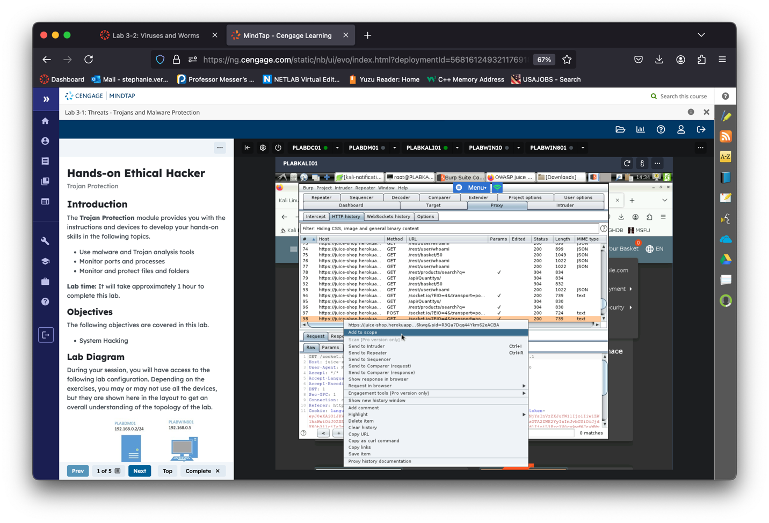

* Say you want to disable logging of traffic for out of scope hosts
* Go to "*Target -> Site map"* see all of the webpages crawled by Burp
* This is a overview of all your target application's content and functionality

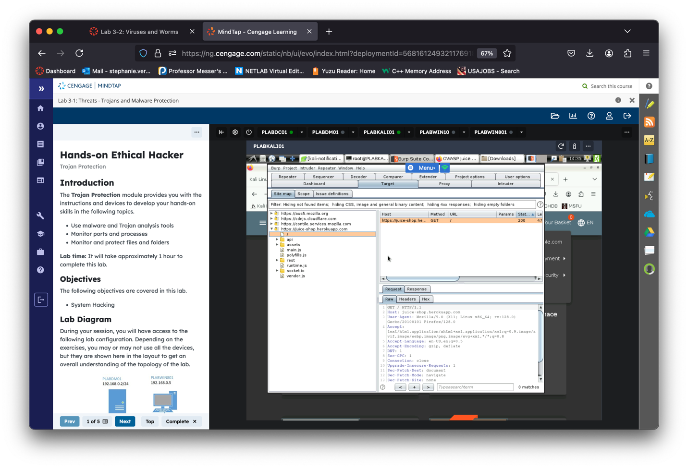

Note: If we had the Pro version of Burp like most professional, we would be able to have it actively scan for vulnerabilities and we'd see it then in the Dashboard

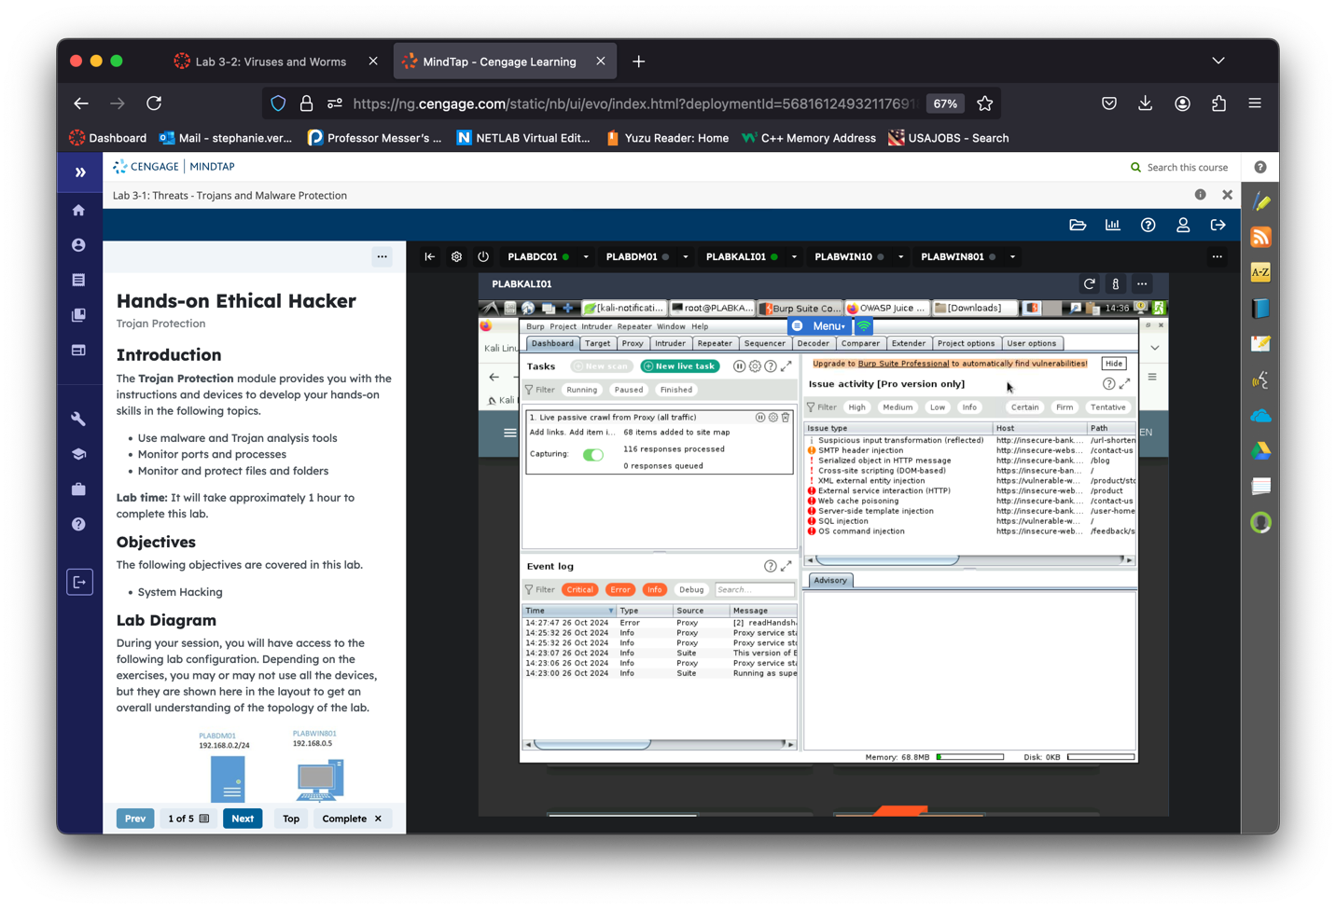

* Test the web application by interacting with it by searching for a product, adding an item to your cart and observe how this affects the requests and responses in Burp Suite

Step 3: Juice Shop Shenanigans

* Go to the "*Proxy -> Intercept*" tab of Burp Suite and toggle "*Turn Intercept on*"
  + This means that any web requests we make will have to be manually forwarded, or modified or dropped, through Burp before going out to the Internet

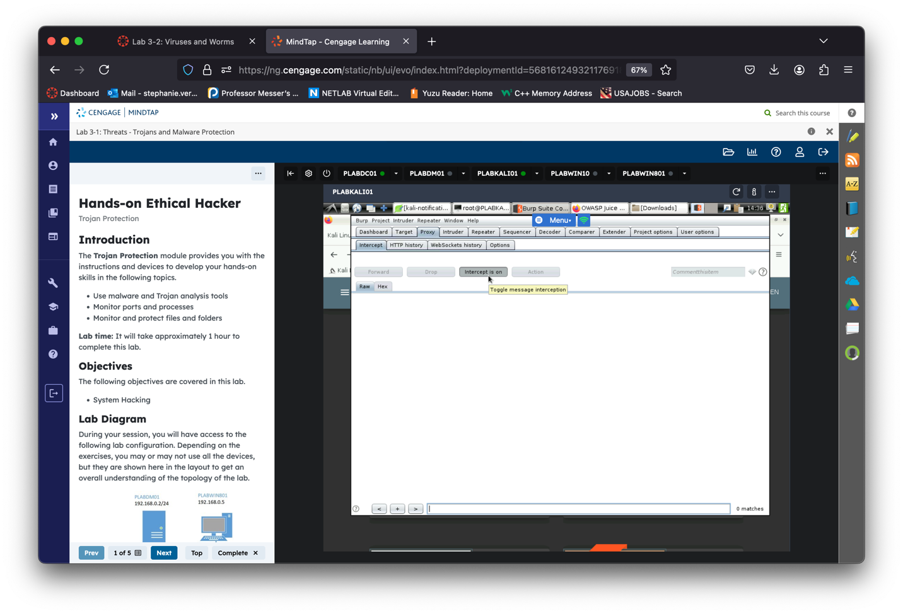

* Go back to the Juice Shop and add an item to your cart
* Click "*Forward"*in Burp until you see the "*POST /api/BasketItems/"*request

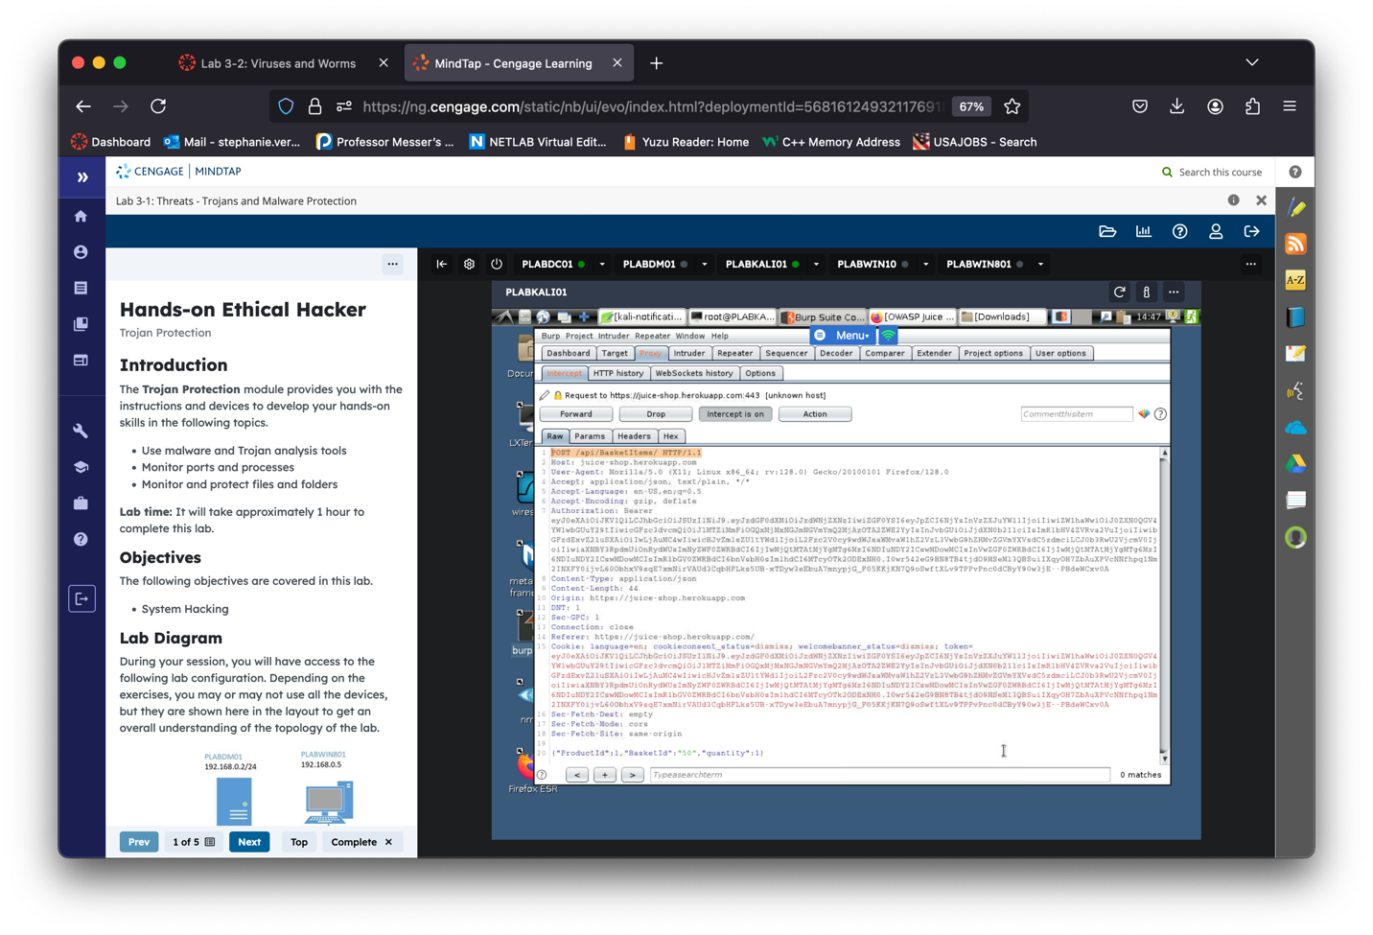

* You can directly edit the request from here, lets modify it from a quantity of *1* to *-1*

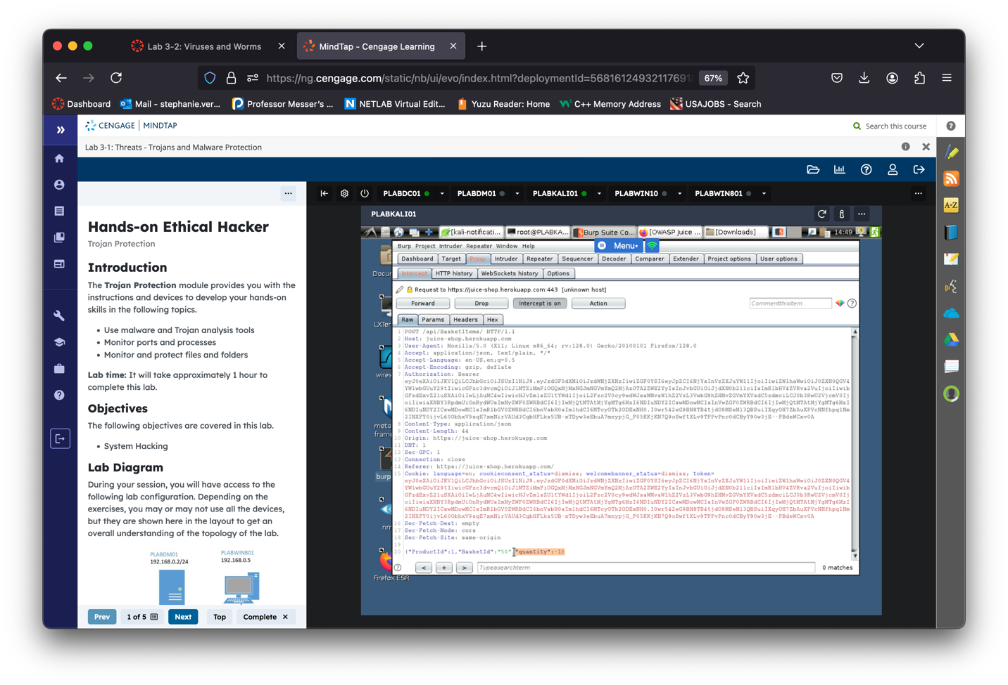

* Click the "*Forward*" button to send the modified response back to your web browser, then toggle "*Intercept is off" for now*
* Observe the modified response in your web browser, we've successful broke their webapp and they now owe us money!

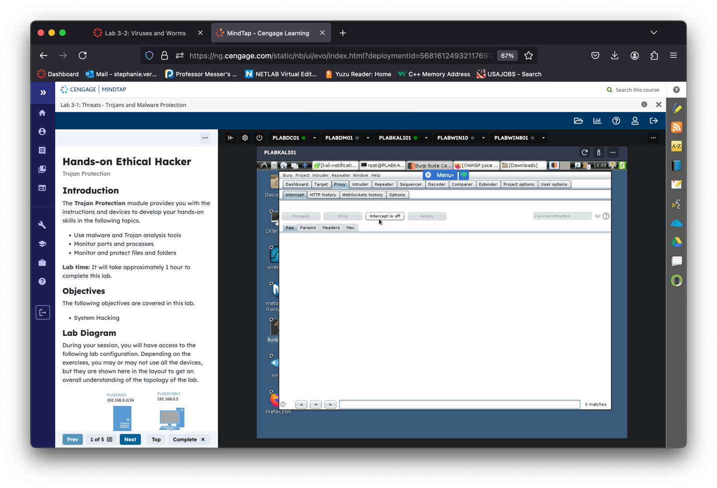

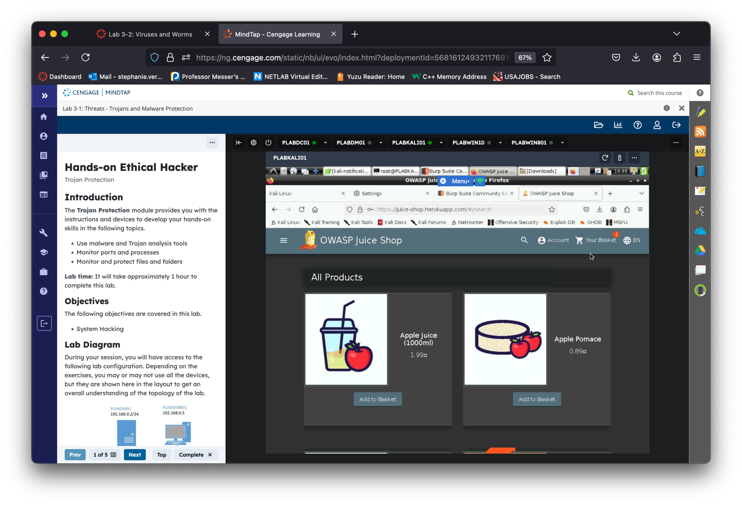

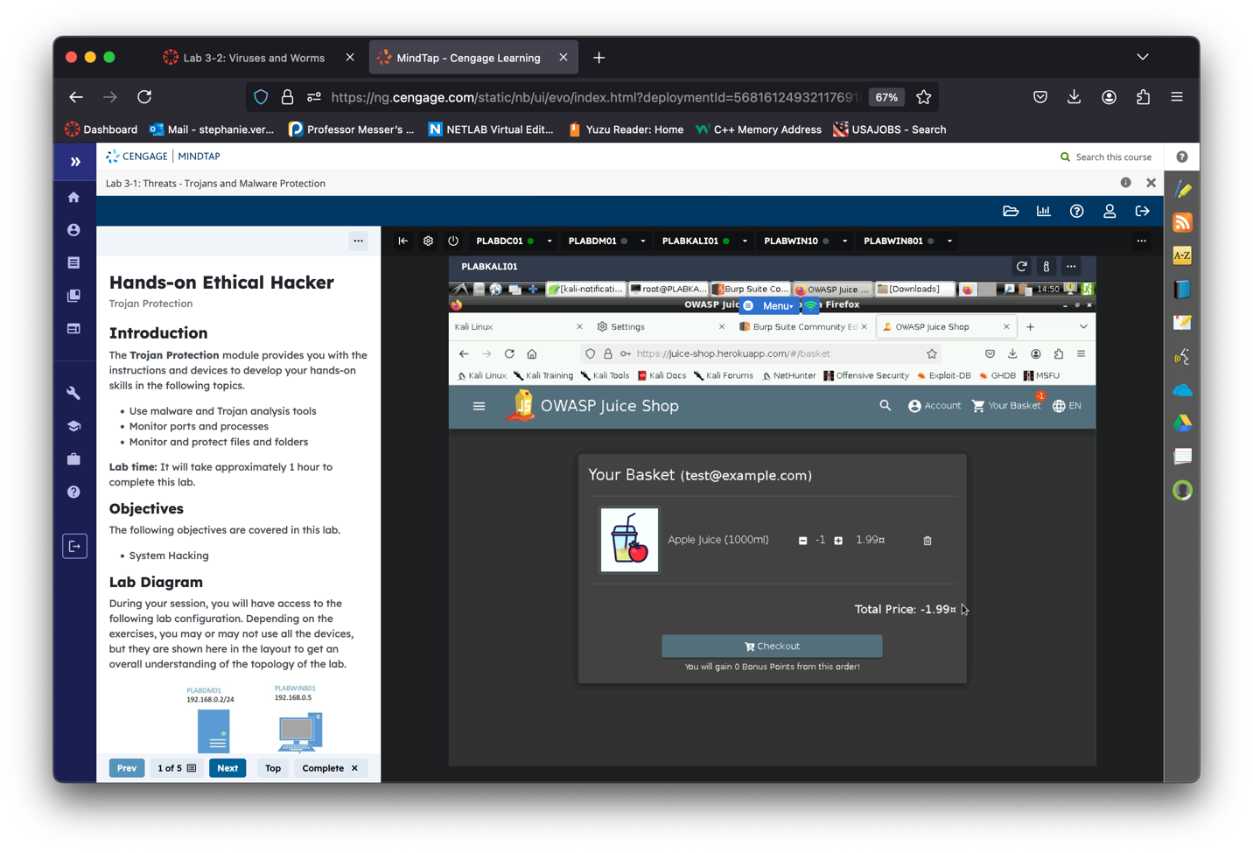

* Log out of the test account now
* Go back to the the login screen again
* Toggle "*Intercept is on"* in Burp
* Type whatever you want for the username and password
* Press "*Log in"*
* On the intercept tab, press "*Forward*" until you see the *"POST /rest/user/login"*request
* Go to *"Action -> Send to Repeater"*

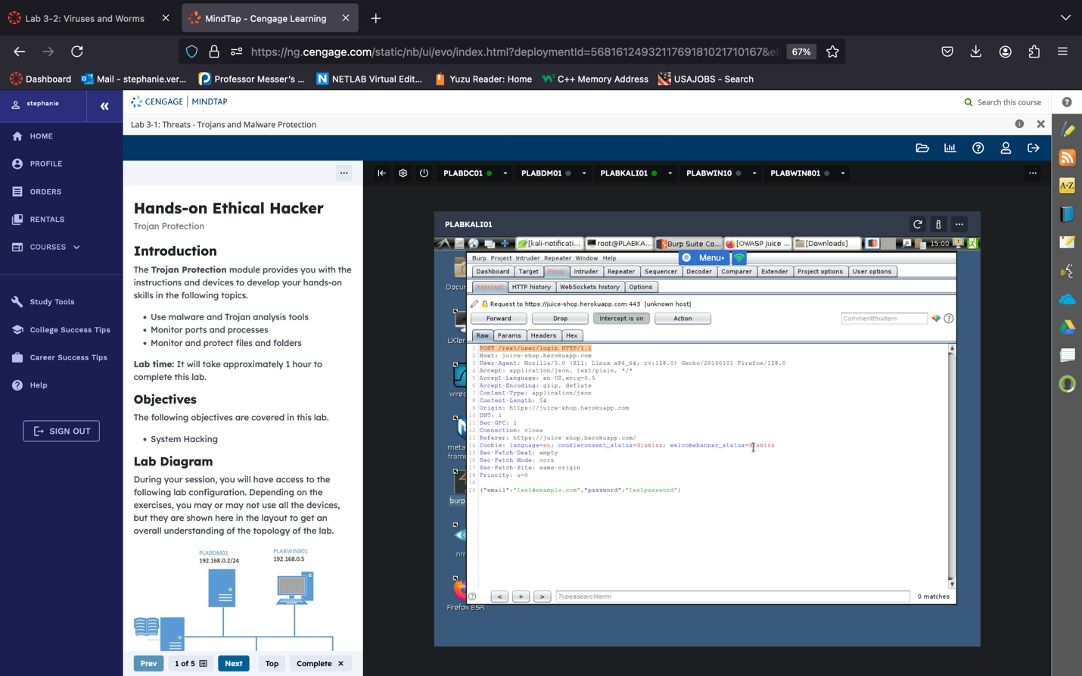

* Go to the Repeater tab
  + Here we can make edits to a type of request. Let's see if it's susceptible to SQL injection
* Under the email section type the following:
  + *;' OR 1=1--*
* Press "*Send"*
* Notice the response gave us a good authentication token for the admin user
* Now we know it works

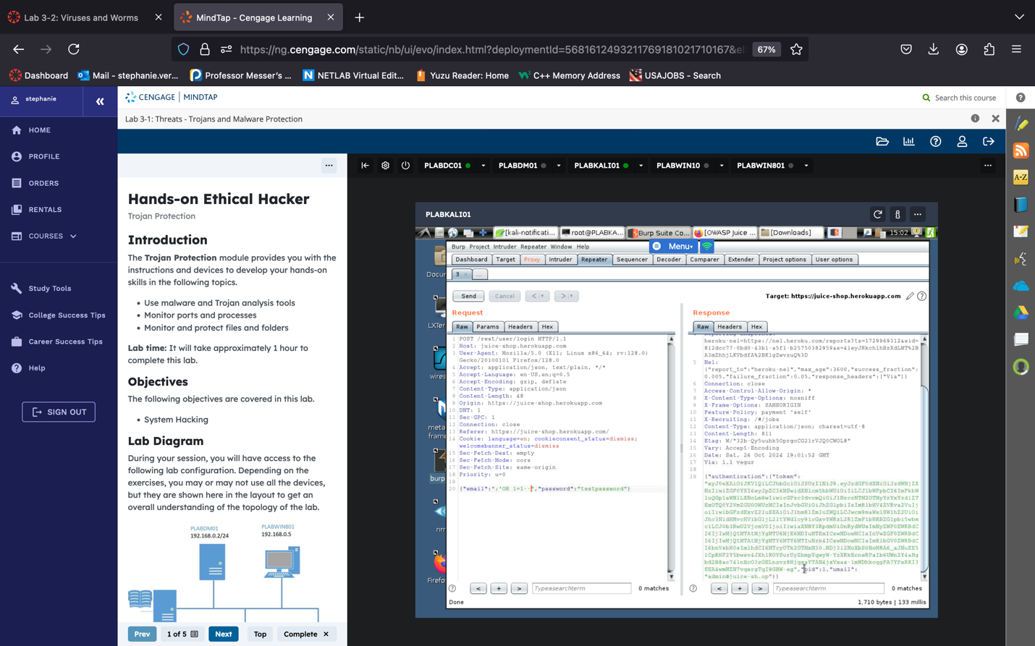

* Toggle *"Turn intercept off"*
* Go back to FireFox and enter this SQLi command in the username field
  + The password can be whatever, it doesn't matter since we are bypassing normal authentication with SQLi anyway

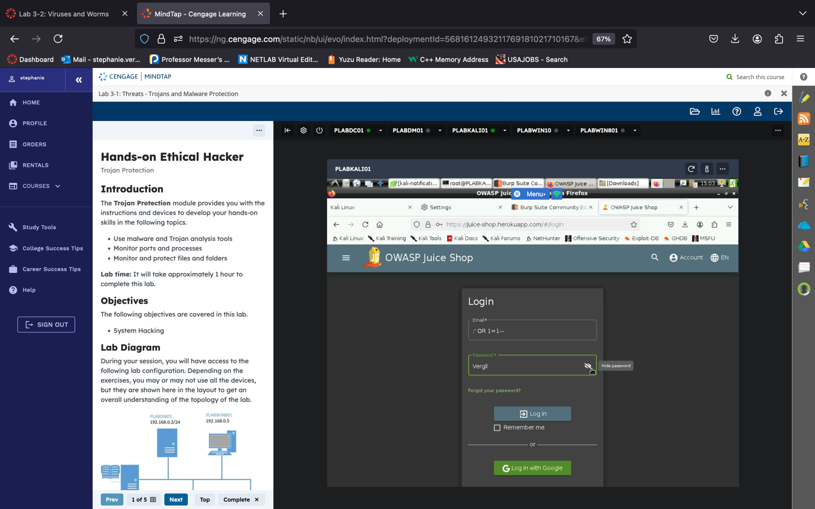

* Notice how you have now successfully logged in as the Admin.

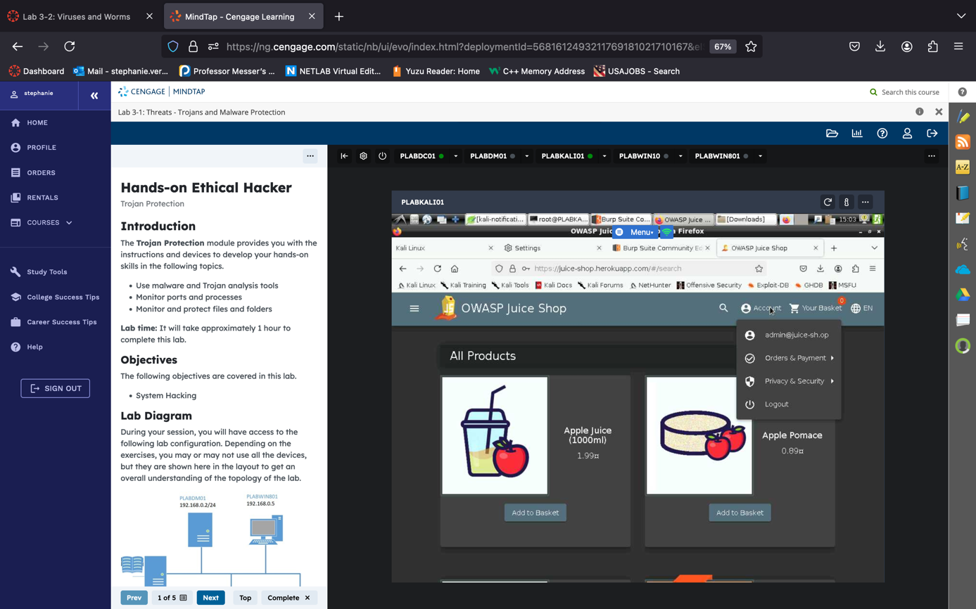

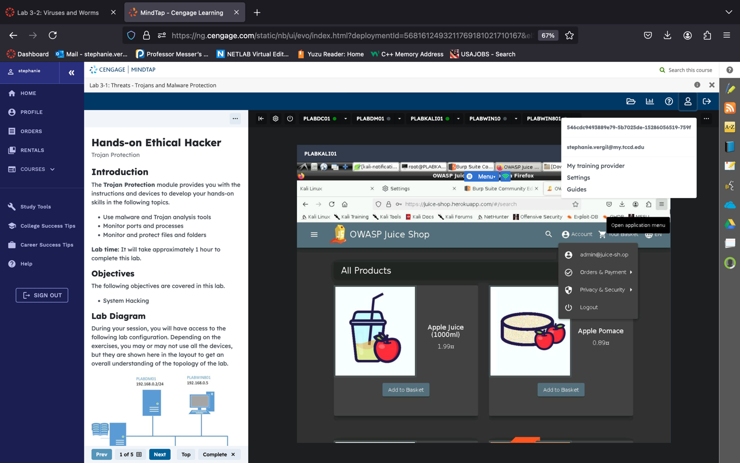

Step 4: Report summarizing findings.

On this lab I used Burp Suite to explore the security of the OWASP Juice Shop application. I started by setting up my Kali VM, but ran into a few issues while updating Firefox ESR, which required some troubleshooting. To resolve the errors, I repaired broken packages, reinstalled Firefox, and ran commands like sudo dpkg --configure -a to reset the package configurations and sudo apt-get install -f to complete any unfinished installs. Once Firefox was updated, I configured both Firefox and Burp Suite to use a proxy, allowing Burp Suite to intercept web traffic between my browser and the Juice Shop application.

After setup, I created a test account in Juice Shop to observe traffic in Burp Suite. With Burp’s Proxy tool, I could intercept and modify specific requests. As shown, I adjusted the item quantity in my cart to -1, which the application accepted, showing how unvalidated inputs could be exploited in unexpected ways.

Next, I tested for SQL injection vulnerabilities using Burp’s Repeater tool. By entering ;' OR 1=1-- in the login field, I was able to successfully bypassed authentication and logged in as an admin, without needing valid credentials. This test revealed a critical vulnerability in the app’s input validation, as it allowed unauthorized access through SQL injection.

This assignment was an eye-opener about the risks of weak input validation, like SQL injection and parameter tampering, and how easily attackers could exploit them if not properly secured. It highlights the importance of secure coding practices for developers to protect web applications from common vulnerabilities that could lead to serious security breaches.